DEVOPS PIPELINE WITH DOCKER COMPOSE FOR AUTOMATED INTEGRATION TESTING

A PROJECT REPORT
(22ITP62-Project Work )

Submitted by

JAYASWATI P

23ITR069

in partial fulfilment of the requirements for the award of the degree
of

BACHELOR OF TECHNOLOGY IN
INFORMATION TECHNOLOGY

DEPARTMENT OF INFORMATION TECHNOLOGY


(Autonomous)

PERUNDURAI ERODE – 638 060
APRIL 2026

DEPARTMENT OF INFORMATION TECHNOLOGY KONGU ENGINEERING COLLEGE
(Autonomous) PERUNDURAI ERODE – 638060
APRIL 2026

BONAFIDE CERTIFICATE

This is to certify that the Project report entitled “Devops Pipeline With Docker Compose For Automated Integration Testing” is the Bonafide record of project work done by and Jayaswati P (23ITR069) in partial fulfilment of the requirements for the award of the Degree of Bachelor of Technology in INFORMATION TECHNOLOGY of Anna University Chennai during the year 2025 - 2026.

SUPERVISOR HEAD OF THE DEPARTMENT

Date: (Signature with seal)

Submitted for the end semester viva voce examination held on .

INTERNAL EXAMINER EXTERNAL EXAMINER

DEPARTMENT OF INFORMATION TECHNOLOGY

KONGU ENGINEERING COLLEGE
(Autonomous) PERUNDURAI ERODE – 638060
APRIL 2026

DECLARATION

I affirm that the Project Report titled “Devops Pipeline With Docker Compose For Automated Integration Testing” being submitted in partial fulfilment of the requirements for the award of Bachelor of Technology is the original work carried out by me. It has not formed the part of any other project report or dissertation on the basis of which a degree or award was conferred on an earlier occasion on this or any other candidate.

JAYASWATI P (23ITR069)

Date:

I certify that the declaration made by the above candidates is true to the best of my knowledge.

Date: Name and Signature of the Supervisor with seal

ABSTRACT

DevOps is a modern software development approach that emphasizes collaboration, automation, and continuous delivery to improve software quality and deployment speed. In this project, a DevOps pipeline is developed using Docker Compose and Jenkins to automate integration testing within a containerized environment.
The pipeline is designed to automatically build, configure, and test applications whenever changes are made to the source code. Docker Compose is used to define and manage multi-container environments, allowing different services such as application servers, databases, and testing tools to run together seamlessly. Jenkins acts as the automation server, orchestrating the entire workflow by triggering builds, running tests, and generating reports.
This automated pipeline ensures that integration testing is performed consistently and efficiently, reducing human errors and saving time. It also provides a scalable and reproducible environment, making it easier to detect and fix bugs early in the development lifecycle. Overall, the implementation demonstrates how DevOps practices combined with containerization can significantly enhance software development productivity, reliability, and deployment efficiency.

ACKNOWLEDGEMENT

First and foremost, abundant grace and the presence of the Almighty are gratefully acknowledged for guiding the project through its different phases and ensuring its successful completion.

Gratitude is expressed to Correspondent THIRU. E. R. K. Krishnan, M.Com., and all the trust members of Kongu Vellalar Institute of Technology Trust for providing the necessary facilities to complete the project successfully.

A deep sense of gratitude is conveyed to the beloved Principal, Dr. R. Parameshwaran M.E., Ph.D., for providing the opportunity to complete this project.

Sincere thanks are extended to Dr. S. Anandamurugan M.E., Ph.D., Head of the Department, Department of Information Technology, for his valuable suggestions.

I am highly indebted to Mr. A. P. Ponselvakumar M.E., Assistant Professor (SLG), Department of Information Technology, for his valuable supervision and guidance towards the successful completion of this project.

I also express my sincere thanks to all the faculty members of the Department of Information Technology for their valuable guidance and support

x

TABLE OF CONTENTS

CHAPTER NO | TITLE | PAGE NO
 | ABSTRACT | iv
 | LIST OF FIGURES | vii
1 | INTRODUCTION  - SCOPE  - OBJECTIVE | 1  1
2 | SYSTEM SPECIFICATIONS  - HARDWARE REQUIREMENTS  - SOFTWARE REQUIREMENTS  - TOOLS SPECIFICATION | 3  3  3
3 | SYSTEM DESIGN  3.1 FLOW CHART | 5
4 | IMPLEMENTATION | 6
5 | RESULT AND CONCLUSIO  - RESULT  - CONCLUSION  - TOOL CREDENTIALS | 8  11  11
 | APPENDIX 1: CODING | 13
 | APPENDIX 2: COURSE CERTIFICATE | 19
 | REFERENCES | 20

FIGURE NO | FIGURE NAME | PAGENO
Figure 1.1 | Flow chart | 5
Figure 2.1 | GitHub Repository | 8
Figure 2.2 | EC2 Instance Setup and Configuration | 8
Figure 2.3 | Docker Destop | 9
Figure 2.4 | Jenkins | 9
Figure 2.5 | Docker compose | 10
Figure 2.6 | Landing web | 10
Figure Appendix2.1 | HCL GUVI Mastering Devops Certificate | 19
LIST OF FIGURES

CHAPTER 1

INTRODUCTION

1.1 SCOPE
- Focuses on setting up a real-time system monitoring solution using Prometheus, Node Exporter, and Grafana on an Ubuntu virtual machine.
- Covers the complete process of collecting system metrics, configuring Prometheus, and displaying data through Grafana dashboards.
- Demonstrates how to track critical system metrics such as CPU usage, memory consumption, and disk space in real time.
- Reinforces the practical understanding of how system monitoring tools can be integrated for better visibility and performance tracking.
- Emphasizes data visualization, continuous system health monitoring, and ease of setup using lightweight tools and configurations.

1.2 OBJECTIVES

The main objectives of this project are:
- To implement an automated DevOps pipeline
- To configure Docker Compose for test environments
- To integrate Jenkins pipeline automation
- To execute integration testing automatically
- To reduce manual testing effort
- To improve software reliability and testing speed

CHAPTER 2

HARDWARE & SOFTWARE REQUIREMENTS

2.1 HARDWARE REQUIREMENTS

- Processor: Intel i3 or higher (Intel i5/i7 recommended for better performance during container builds and parallel testing)
- RAM: Minimum 4 GB (8 GB or higher recommended for smooth execution of multiple Docker containers)
- Storage: Minimum 10 GB of free disk space (SSD preferred for faster read/write operations)
- Network: Stable internet connection for downloading dependencies, Docker images, and Git repositories

2.2 SOFTWARE REQUIREMENTS

Operating System: Windows, Linux, or macOS (Linux preferred for better container performance and compatibility)

Docker Desktop: Used to create, run, and manage containers. It allows applications and their dependencies to be packaged together, ensuring consistency across environments.

Docker Compose : Helps define and manage multi-container Docker applications using a YAML configuration file. It is essential for setting up integration testing environments.

Jenkins: An open-source automation tool used to build, test, and deploy applications. It plays a key role in implementing the CI/CD pipeline.

TOOLS SPECIFICATION

2.3.1 GitHub

GitHub is a widely used platform for version control and collaborative software development. It allows developers to store, manage, and track changes in their code using Git.

In this project, GitHub is used as the central repository to maintain the source code of the application. It enables efficient collaboration and version management through features like branching and merging.

2.3.2 Docker

Docker is an open-source platform used to develop, ship, and run applications inside lightweight containers. It packages the application along with its dependencies, ensuring consistency across different environments.

In this project, Docker is used to containerize the Node.js-based application for integration testing. A Dockerfile is created to define the runtime environment, dependencies, and execution steps. This ensures that the application behaves the same in development, testing, and deployment environments, eliminating compatibility issues.

2.3.3 Docker Hub

Docker Hub is a cloud-based repository service used for storing and managing Docker images. It allows developers to push and pull images for deployment across different systems.

In this project, Docker Hub is used to store the Docker image after it is built through the CI pipeline. The image is tagged and pushed to Docker Hub, making it easily accessible for deployment and reuse.

2.3.4 Jenkins

Jenkins is an open-source automation server used to implement Continuous Integration and Continuous Delivery (CI/CD) pipelines. It automates tasks such as building, testing, and deploying applications.

In this project, Jenkins is used to design and execute the CI pipeline. It is integrated with GitHub through webhooks to automatically trigger the pipeline whenever code is pushed. The pipeline includes stages such as:

Source code checkout

Dependency installation

Application build

CHAPTER 3

SYSTEM DESIGN

3.1 FLOW CHART
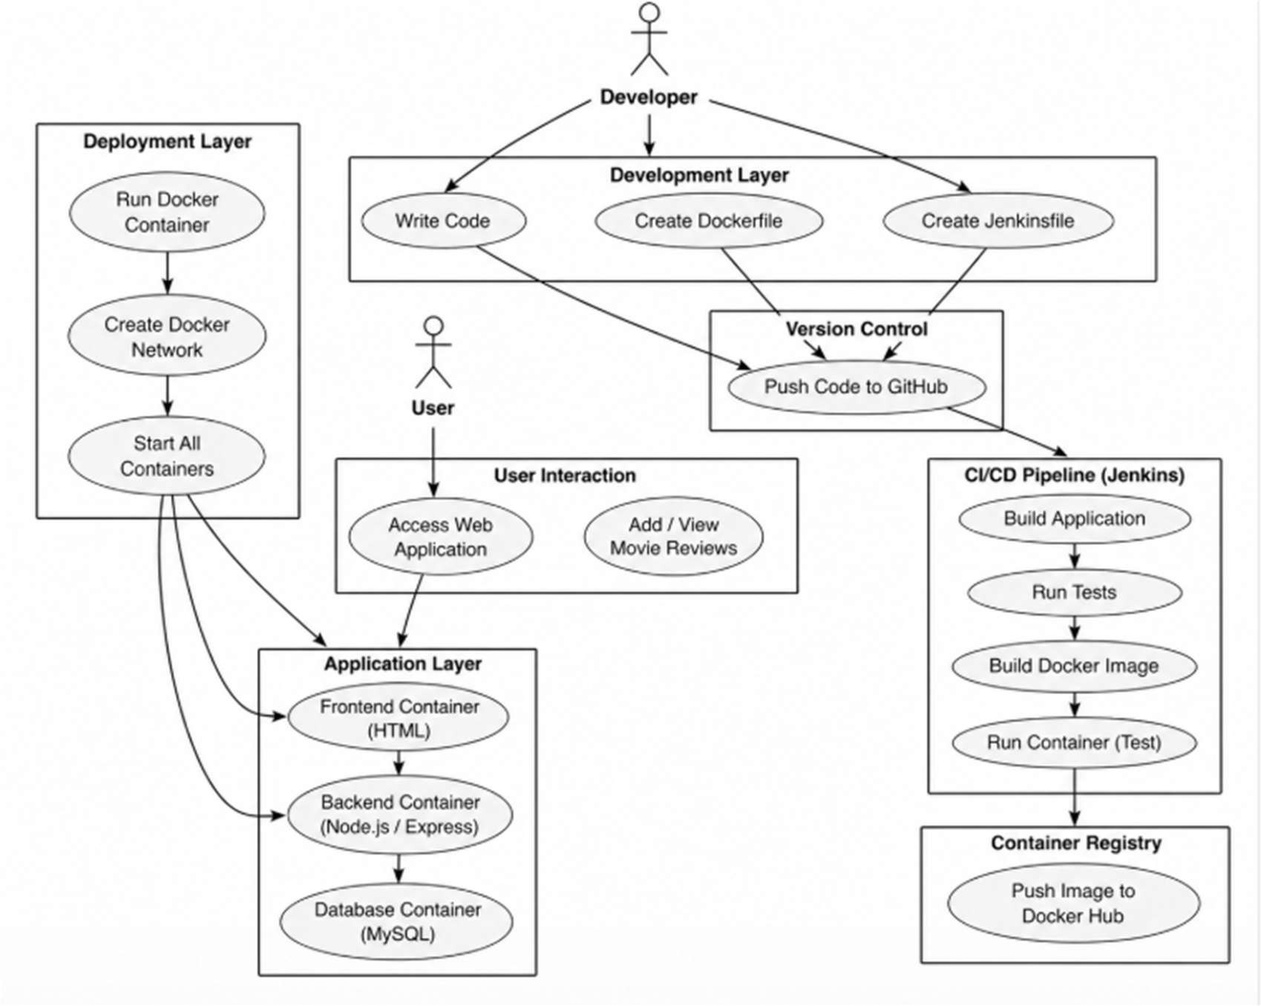
The flow chart represents the workflow of the Movie Review System integrated with a Continuous Integration (CI) pipeline using Jenkins and Docker. The developer writes the application code and pushes it to GitHub, which acts as the version control system. A webhook triggers the Jenkins pipeline automatically whenever changes are made. Jenkins then builds the application, installs dependencies, and runs test cases to ensure proper functionality. After successful testing, a Docker image is created and the application is run inside a container for validation. The verified Docker image is pushed to Docker Hub for storage and deployment. Finally, users can access the application and perform operations such as adding and viewing movie reviews, completing the automated CI workflow.
Figure 1.2: FlowChart

CHAPTER 4 IMPLEMENTATION
Application Layer
The application developed in this project is an Integration Testing System designed to demonstrate a DevOps pipeline workflow. It includes core functionalities such as building the application, running automated test cases, and validating outputs. The application is developed using Node.js and supporting technologies, and it is first tested in a local environment to ensure correctness before being integrated into the Continuous Integration (CI) pipeline.
Containerization Layer
To ensure portability and consistency, the application is containerized using Docker. A Dockerfile is created to define the application environment, including dependencies, runtime configurations, and execution commands. This ensures that the application runs uniformly across different systems without compatibility issues. The containerized approach isolates the application and simplifies deployment.
Configuration Layer
The CI/CD pipeline is configured using Jenkins, which acts as the automation server. A Jenkinsfile is written to define various stages of the pipeline such as source code checkout, build process, test execution, Docker image creation, and deployment. The source code is maintained in GitHub, and a webhook is configured to automatically trigger the pipeline whenever changes are pushed to the repository.
Automation Layer
Automation is handled entirely by Jenkins, which executes the pipeline steps without manual intervention. It performs tasks such as installing dependencies, building the application, running integration tests, and validating results. This ensures that every code change is automatically tested, reducing human errors and improving development efficiency. Early detection of bugs helps maintain software quality.

Networking Layer
The networking layer is responsible for communication between different components of the system. Docker uses a bridge network to enable interaction between containers. If required, services like backend and database can communicate seamlessly using container names and environment variables. This ensures reliable data exchange and service integration during testing.
Execution and Validation Layer
After building the Docker image, the application is executed within a container to verify its functionality. The container runs on a specified port, and integration tests are performed to validate application behavior. This stage ensures that the application works correctly in a real runtime environment before deployment.
Deployment Layer
Once the application successfully passes all testing stages, the Docker image is pushed to a container registry such as Docker Hub. This allows version control, easy access, and reuse of the application image for deployment in different environments. The deployment process becomes faster and more reliable through automation.
Communication Layer
End users or developers can access the application through a web interface using a browser. The system provides outputs of test execution and application status. The integration of Jenkins, Docker, and GitHub creates a seamless workflow where code changes are automatically built, tested, and made available for use.

CHAPTER 5

RESULT AND CONCLUSION
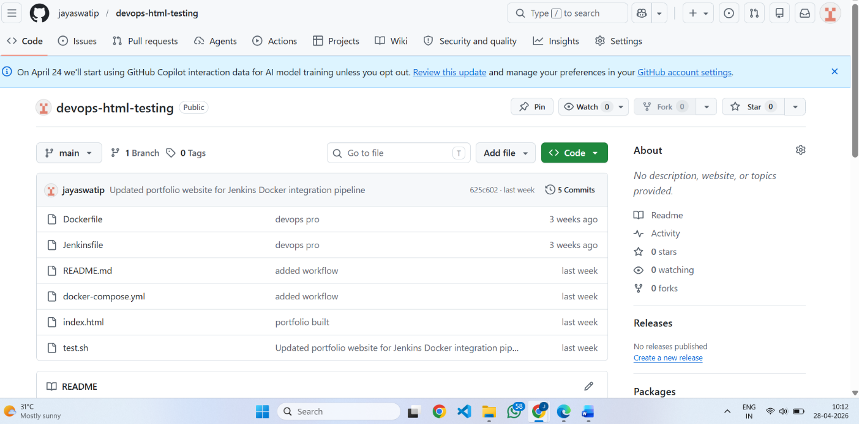
5.1 RESULT
Figure 2.1: GitHub Repository

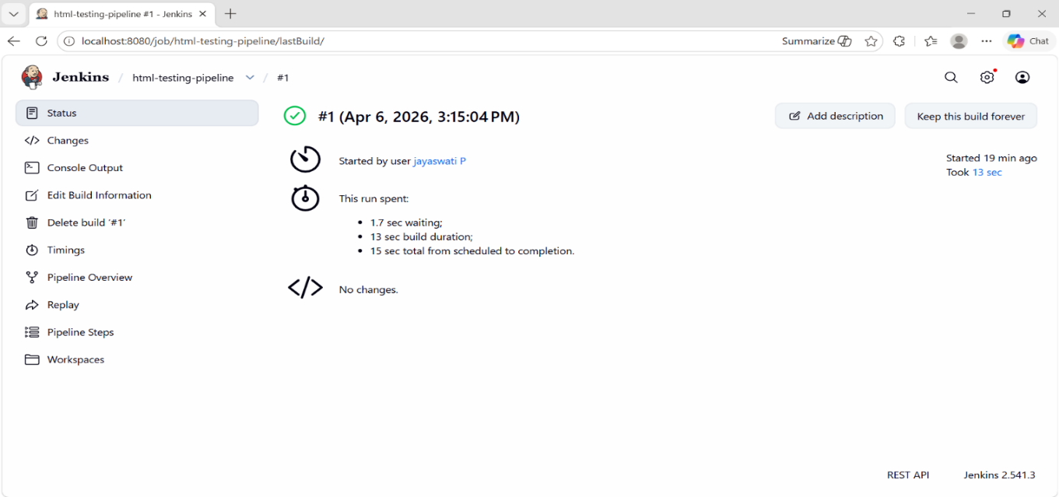

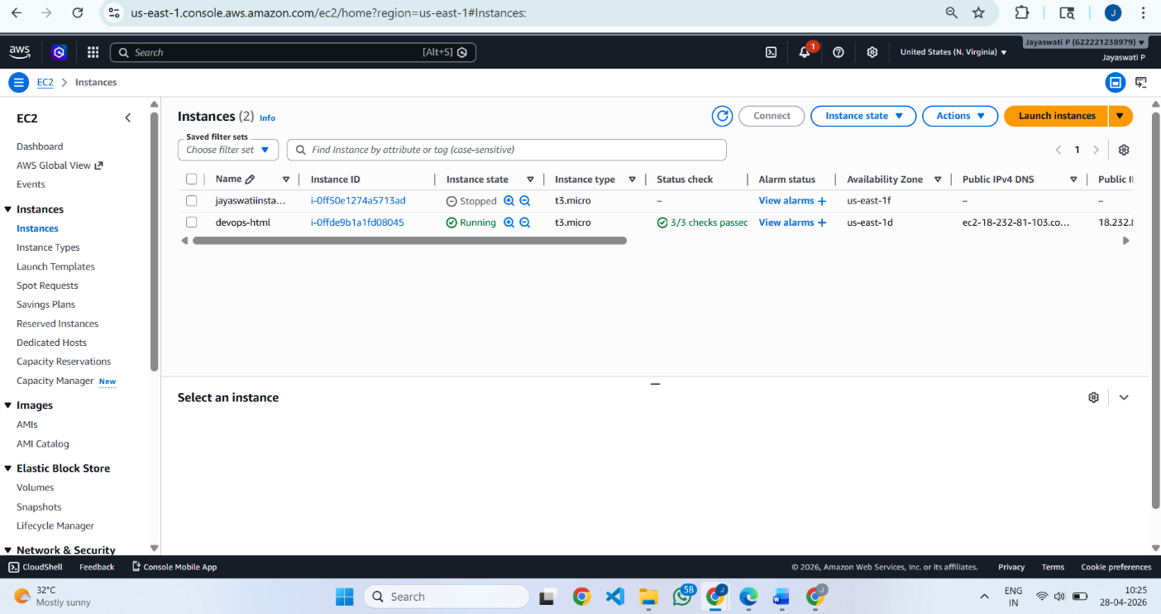
Figure 2.2: EC2 Instance Setup and Configuration

Figure 2.3: Docker Destop

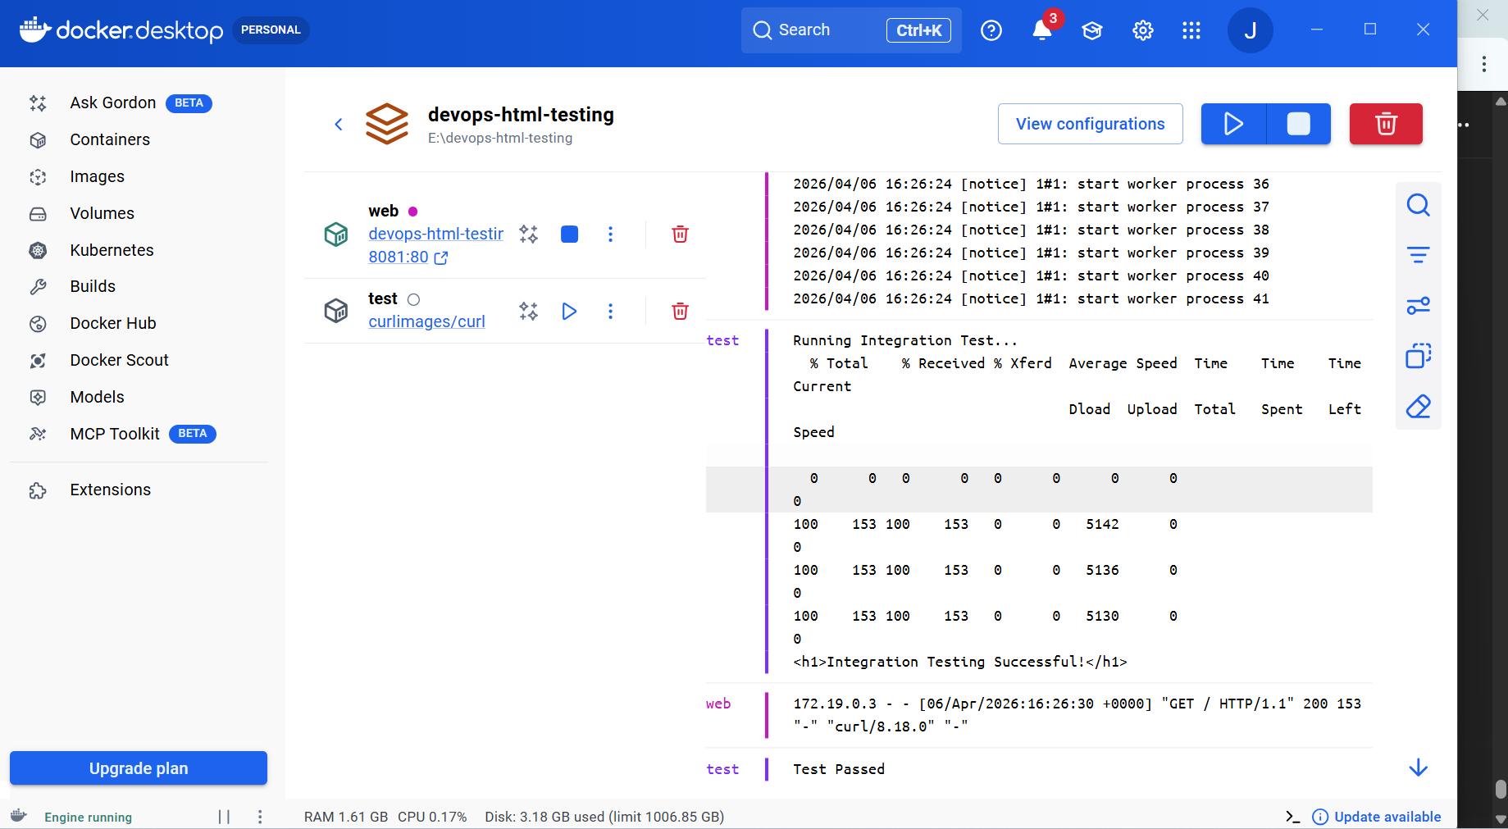
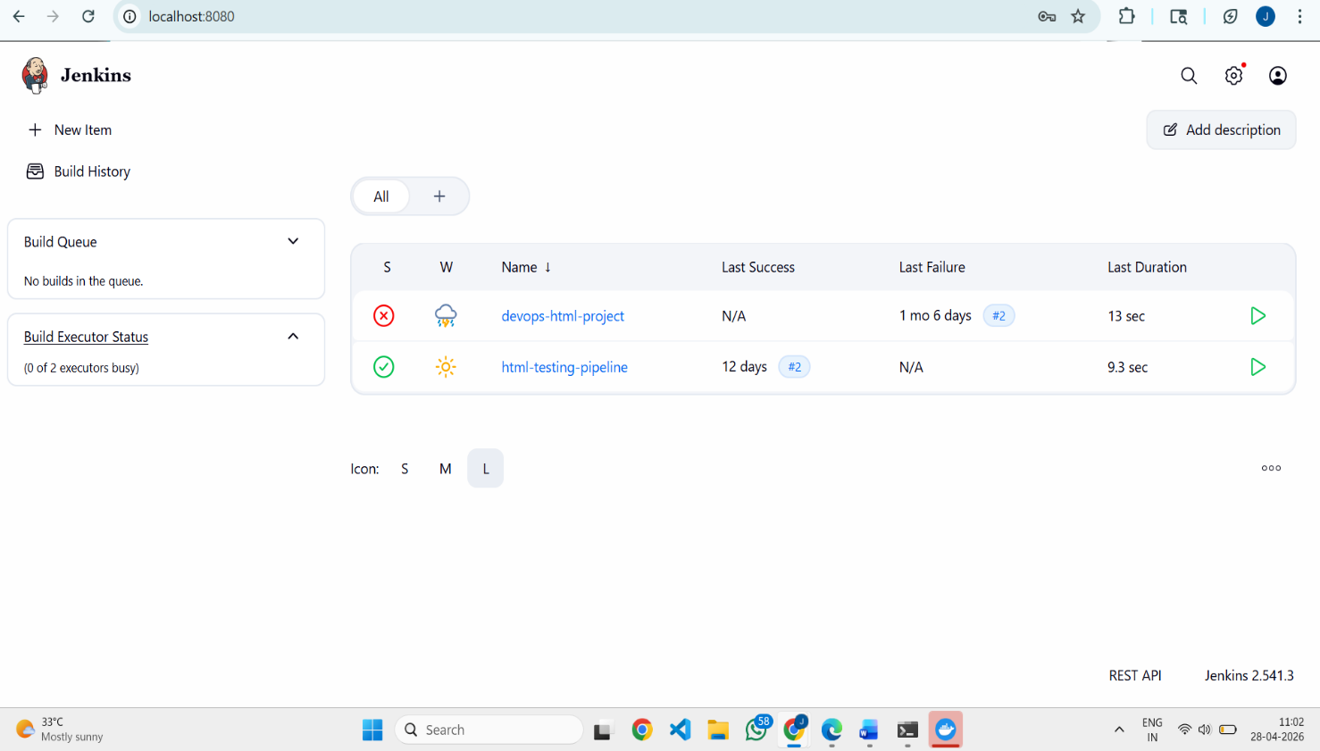

Figure 2.4: jenkins

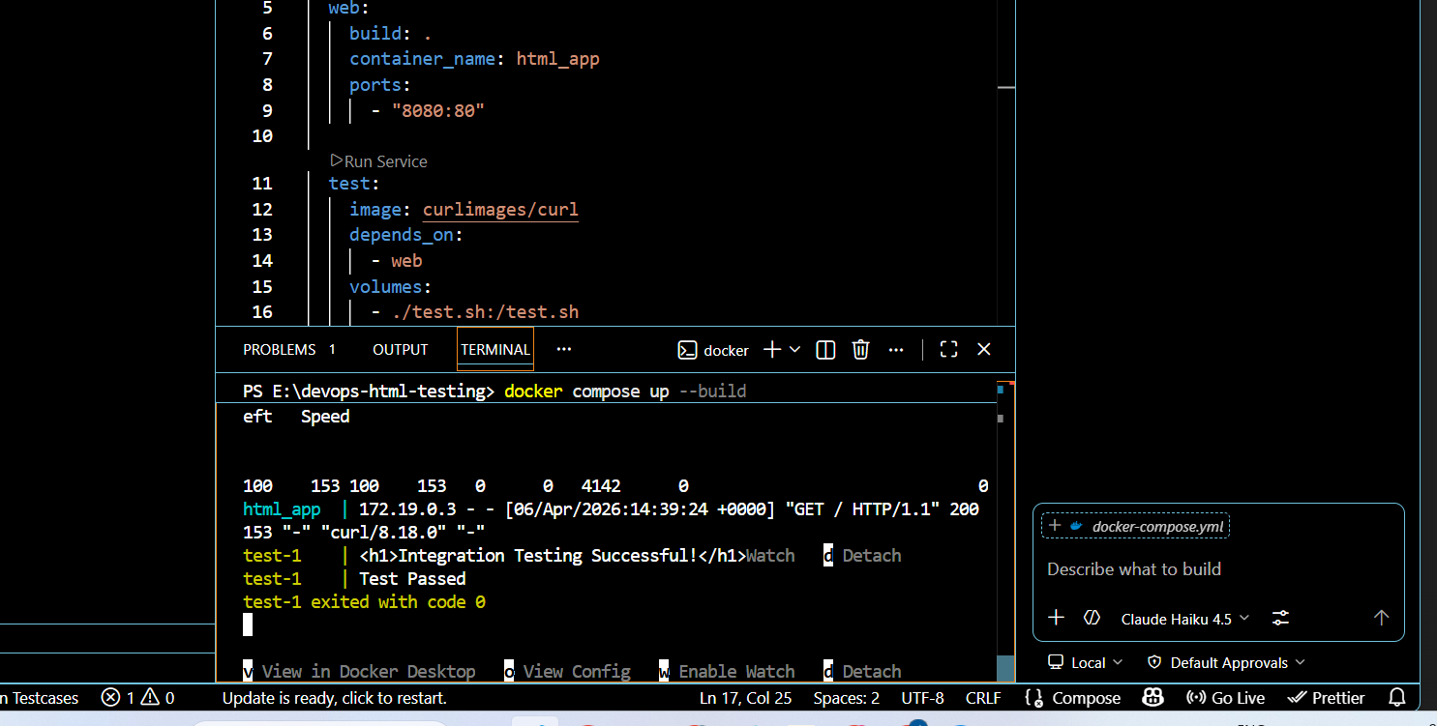
Figure 2.5: docker compose

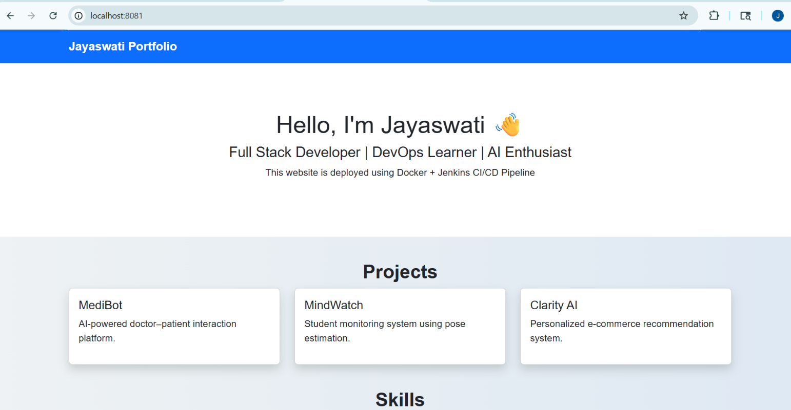

Figure 2.6: Landing web

5.2 CONCLUSION

Implementing a DevOps pipeline using Jenkins and Docker Compose provides an efficient solution for automated integration testing. Jenkins automates the pipeline workflow, while Docker Compose creates consistent containerized environments for executing tests.
This approach ensures faster development cycles, reduces manual configuration effort, and improves testing reliability. The pipeline supports scalable testing environments and can be extended for Continuous Deployment in future applications. Overall, the project demonstrates how container-based DevOps automation enhances software quality and productivity.

TOOL CREDENTIALS

Github

ID – jayaswatip
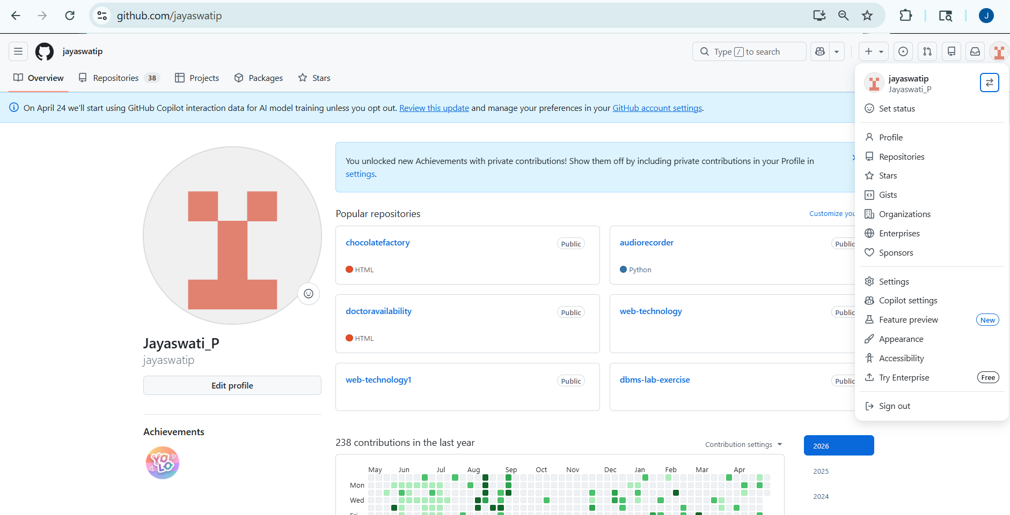

Docker

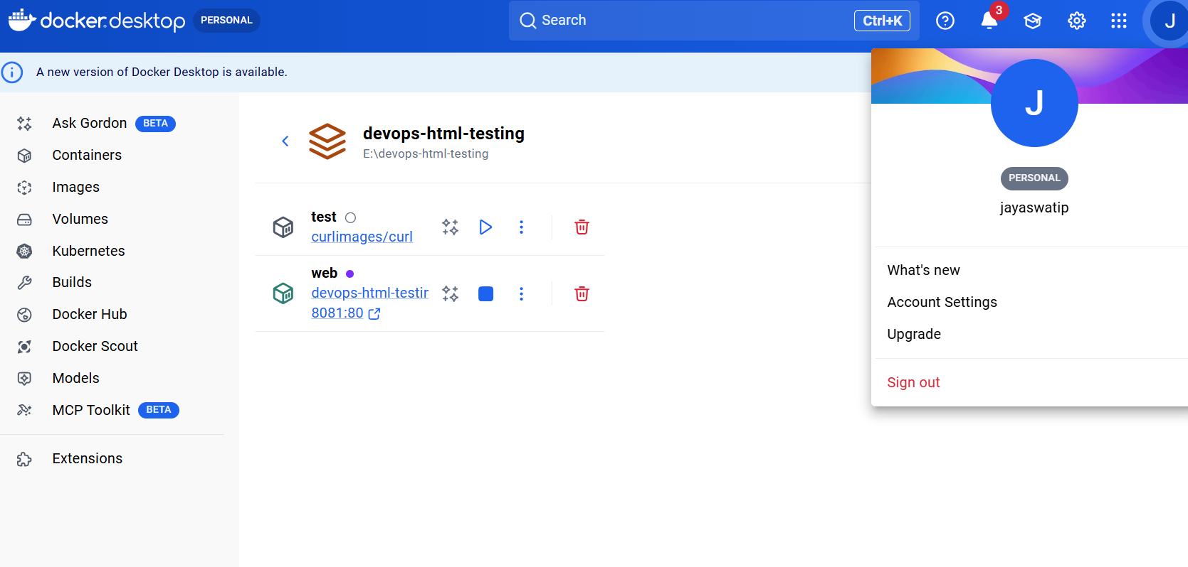
ID – jayaswatip
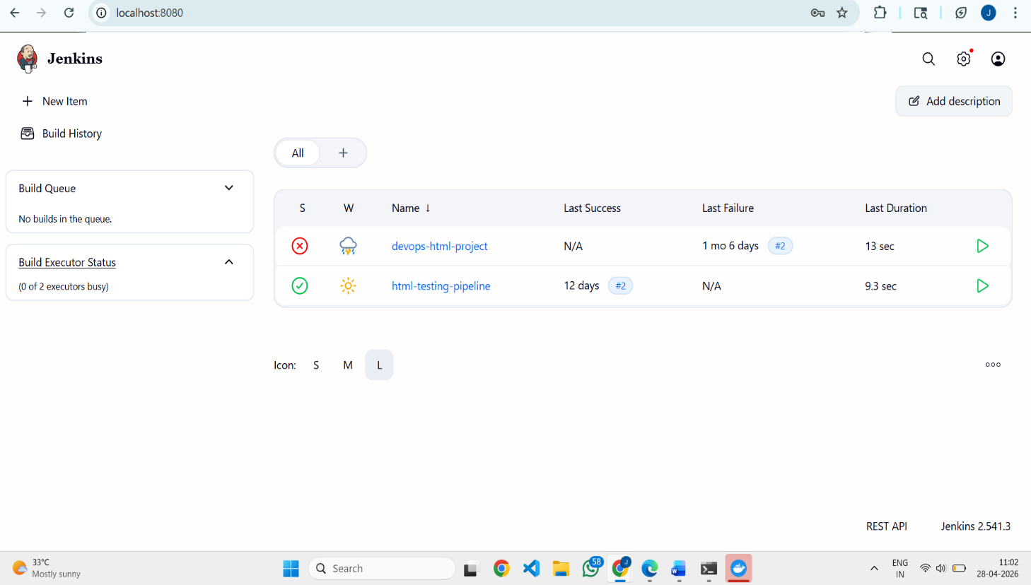

    - Jenkins

ID - jayaswati

APPENDIX 1: CODING

<!DOCTYPE html>
<html lang="en">

<head>
<meta charset="UTF-8">
<meta name="viewport" content="width=device-width, initial-scale=1.0">

<title>Jayaswati Portfolio</title>

<link href="https://cdn.jsdelivr.net/npm/bootstrap@5.3.0/dist/css/bootstrap.min.css" rel="stylesheet">

<style>

body{
background: linear-gradient(to right,#eef2f3,#dfe9f3);
font-family: Arial;
}

.navbar{
background:#0d6efd;
}

.navbar-brand{
color:white;
font-weight:bold;
}

.hero{
padding:80px;
text-align:center;
background:white;
}

.section-title{
margin-top:40px;
text-align:center;
font-weight:bold;
}

.card{
transition:0.3s;
}

.card:hover{
transform:scale(1.05);
}

.footer{
background:#222;
color:white;
text-align:center;
padding:15px;
margin-top:40px;
}

</style>

</head>

<body>

<!-- NAVBAR -->

<nav class="navbar">
<div class="container">
<a class="navbar-brand">Jayaswati Portfolio</a>
</div>
</nav>

<!-- HERO -->

<section class="hero">

<h1>Hello, I'm Jayaswati 👋</h1>

<h4>Full Stack Developer | DevOps Learner | AI Enthusiast</h4>

<p>This website is deployed using Docker + Jenkins CI/CD Pipeline</p>

</section>

<!-- PROJECTS -->

<div class="container">

<h2 class="section-title">Projects</h2>

<div class="row">

<div class="col-md-4">

<div class="card shadow">

<div class="card-body">

<h5>MediBot</h5>

<p>AI-powered doctor–patient interaction platform.</p>

</div>

</div>

</div>

<div class="col-md-4">

<div class="card shadow">

<div class="card-body">

<h5>MindWatch</h5>

<p>Student monitoring system using pose estimation.</p>

</div>

</div>

</div>

<div class="col-md-4">

<div class="card shadow">

<div class="card-body">

<h5>Clarity AI</h5>

<p>Personalized e-commerce recommendation system.</p>

</div>

</div>

</div>

</div>

</div>

<!-- SKILLS -->

<div class="container">

<h2 class="section-title">Skills</h2>

<p class="text-center">

Python | React | Node.js | MongoDB | AWS | Docker

</p>

</div>

<!-- DEVOPS SECTION -->

<div class="container">

<h2 class="section-title">DevOps Pipeline Demo</h2>

<p class="text-center">

This portfolio is automatically deployed using:

Docker Containerization
Jenkins CI/CD Pipeline
Integration Testing Workflow

</p>

</div>

<!-- REQUIRED TEST LINE (DO NOT REMOVE) -->

<div style="text-align:center;color:green;font-weight:bold;">

Integration Testing Successful

</div>

<!-- FOOTER -->

<div class="footer">

© 2026 Jayaswati | DevOps Pipeline Portfolio

</div>

</body>
</html>

COMMANDS
1. Install Docker
sudo apt update
sudo apt install docker.io
Start Docker:
sudo systemctl start docker
sudo systemctl enable docker
2. Install Docker Compose
sudo apt install docker-compose
Verify installation:
docker-compose --version
3. Run Jenkins Container
docker run -p 8080:8080 jenkins/jenkins:lts
Access Jenkins:
http://localhost:8080
4. Create docker-compose.yml File
version: '3'
services:
web:
image: nginx
ports:
- "8081:80"
test:
image: alpine
command: echo "Integration Testing Successful"
Run Docker Compose:
docker-compose up -d
5. Jenkins Pipeline Script
pipeline {
agent any
stages {
stage('Clone Repository') {
steps {
git 'https://github.com/sample/project.git'
}
}
stage('Run Docker Compose') {
steps {
sh 'docker-compose up -d'
}
}
stage('Run Tests') {
steps {
sh 'docker-compose run test'
}
}
stage('Stop Containers') {
steps {
sh 'docker-compose down'
}
}

APPENDIX 2: COURSE CERTIFICATE

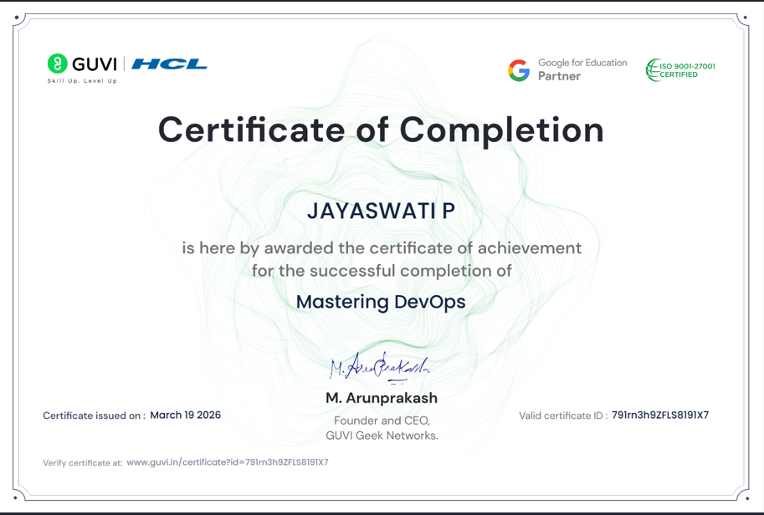

Figure Appendix 2.1: HCL GUVI Mastering DevOps Certificate

GITHUB REPOSITORY LINK

https://github.com/jayaswatip/devops-html-testing

REFRENCES

- Docker Official Documentation
https://docs.docker.com
- Jenkins Official Documentation
https://www.jenkins.io/doc/
- Docker Compose Documentation
https://docs.docker.com/compose/
- DevOps Concepts Guide
https://azure.microsoft.com/en-in/resources/devops-guide

